Financial Avenue on the UL website

On ASC’s website (under “Services”)

UL and The Knowl are here to help you get “Knowl-edgeable” about Money!
We’re here to give you a leg up on financial education via an online program called, Financial Avenue. The idea is to provide you with smart resources to help demystify the world of personal finance. Trust us – getting a handle on your money doesn’t have to feel overwhelming or restrictive. It’s all about empowering yourself with smart basics, and planning from there.
With the Money Mascot, the Knowl, as your trusty guide, you will have access to ten short online courses, with videos, interactive tools, and customized action plans at the end of each course.
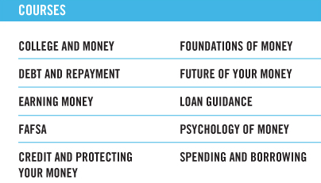

With all these tools, we’ve made it pretty easy to know exactly what you can begin doing RIGHT NOW to put your financial knowledge to good use. After all, the Knowl says there’s no time like the present.
Get Started by setting up your FREE private account at FinancialAvenue.org. Once there, just click the “Login” link at the top of the page, click to sign up as a student and then provide your access code shown below. To create your account, you’ll need your school specific email address and a password of your choosing.
Access code is: xg4d62
Follow the #Knowl
Also, the Knowl would appreciate it if you followed him @MoneyKnowl and #Knowl. He’ll be sure to make it worth your while by sharing tips, resources and strategies to help you become a Money Mastery Ninja.

